CALGARY BALLOON CLUB PRE-ANNOUNCEMENTS:

If you were not able to attend the Calgary Balloon Club’s 46th anniversary celebration on September 17, or you found yourself too busy during the night to make your bid or purchase, you might be interested in the 50/50 draw and the special silent auction that will be finalized at 7:30 pm at the club’s monthly meeting on Wednesday, October 12, 2022 at the Rothney Observatory.
Tickets can be purchased in person or via online and etransfer.
- 50/50 TICKETS:
50/50 tickets are available for sale.
- cost of the tickets are:
  - 1 for $5.00
  - 3 for $10.00. or
  - 15 for $20.00
- First place Winner takes 35% of the ticket sales.
- Second place winner takes 15% of the ticket sales.
- You can send in an etransfer via the Calgary Balloon Club to luxen@shaw.ca, specifying the number of tickets that you would like to purchase.
- One side of the double ticket will be put into the dropbox, and the other side will be given to you, either by email or in person.
- Tickets will also be available during the High River event.
- SILENT AUCTION:
Thanks to a generous donation from Ralph Dowson, we have several items that will be offered for sale to the public on the weekend of October 19 - 21 at the Clarion Hotel Estate sale.
More information on this sale will be sent out to club members in the next announcements.
In advance of that, we are holding a silent auction on two of the items that will only be offered through the club.
- You can bid on the items by emailing or texting Lindathen@telus.net or 403-874-0160 with your bid. The latest bid, determined by the time it was submitted, will be posted on the Calgary Balloon Club website: calgaryballoonclub.ca.
- The winner will be the bid with the highest offer as of 7:30 PM on Wednesday, October 12, 2022
These are great for collectors and make amazing Christmas or birthday gifts.

Item 1:
- Franklin Mint - 25 piece pewter locomotive miniatures with wooden display case.
  - Collection is valued at $375.
  - The current latest bid for this item is $150.
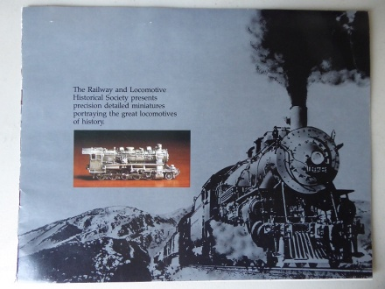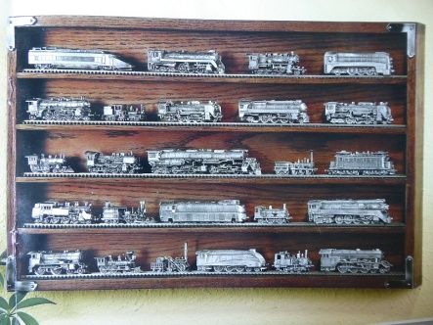

Item 2:
  - A framed set of 62 pins of “Flags of the Nations”from the 1988 Calgary Olympics featuring Hindu and Howdy.
  - Value of $180
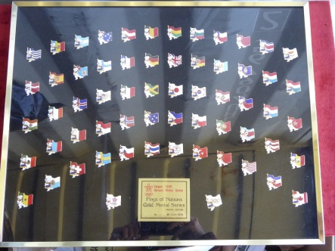
  - The current, latest bid for this item is $100.

Anniversary Wine Bags:
The club has special anniversary wine bags available for sale as well. They can be purchased for: 1 for $10.00 or 3 for $20.00.
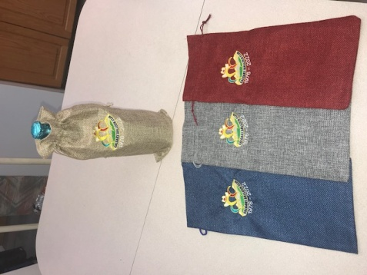
The wine bags will be available for sale during the High River weekend but can also be purchased by contacting the club at calgaryballoonclub@gmail.com and etransfer to luxen@shaw.ca

Great for tailgating or Christmas hostess or birthday gifts.

MARK ON YOUR CALENDAR…

Also, a heads up to all club members for a very interesting evening at the next club meeting on Wednesday, October 12. We will be going to the Rothney Observatory, out near Millerville, courtesy of club member Dr. Alan Clark.
We are asking members to arrive at 6:45 so that we may conduct our monthly meeting. Following the meeting, we will have a tour of the observatory and have time to spend with some of the telescopes. Under Alan‘s guidance and the rest of the observatory staff, this will make a very interesting evening not to be missed.
Young people and friends will be welcome.
Further information and a map will be sent out with the club announcements on or around October 9.

